PROJECT ANIMAL IDENTIFICATION FORM - RABBIT

MEMBER INFORMATION
Member’s Name |  |  |  | Date of Birth (Y/M/D) __________________ Age as of Jan. 1, 2016:
Address |  |  |  | Club
 |  |  |  | Postal Code
Parent/Guardian |  |  |  | Telephone # ( )
Email address
PROJECT INFORMATION
Rabbit’s name: |  |  | Tattoo or Tag number, in any:
Purebred Yes ◻ No ◻ |  | Breed (s) |  |  | Sexe of rabbit
Does your rabbit have: short hair ◻ or long hair ◻
What is the intended purpose of your rabbit? (select more than 1 if applicable)
Meat ◻   Show ◻   Fur ◻   Pet ◻   Wool ◻   Breeding Stock ◻   Combination ◻ 
If purchased, from where?
Name and address where your rabbit is housed:

Are you interested and eligible to participate in:
Quebec 4-H Provincial Rally Yes□ No□ 
Attach a photo showing all markings on your rabbit, or draw markings below, making sure to indicate colours.
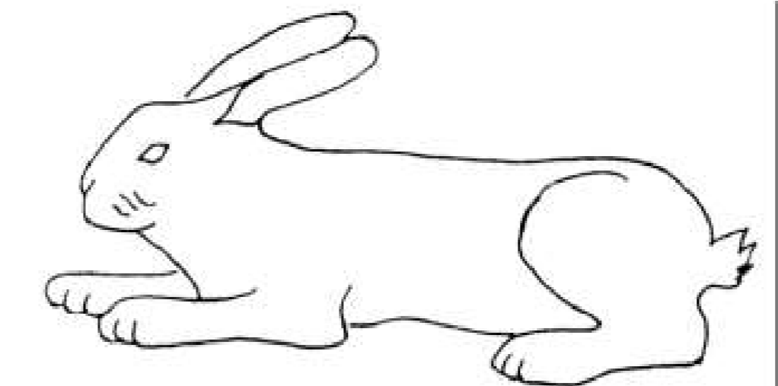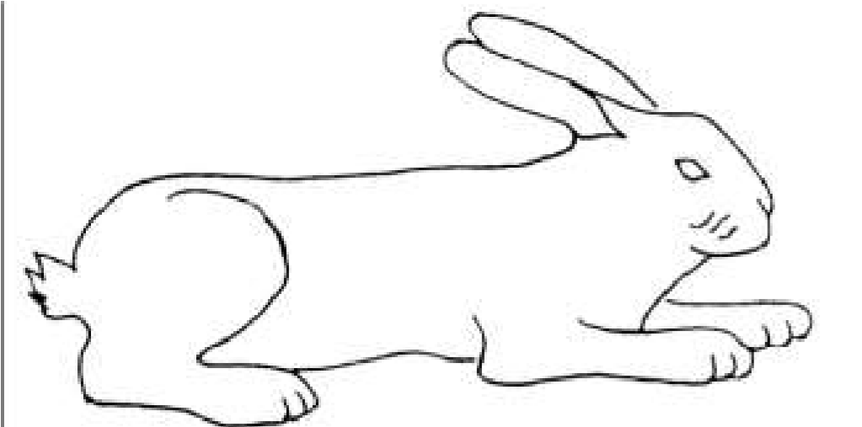
Member: I declare that the above information is correct. I am a bona fide 4-H member and the above animal is my current 4-H project.
Signature ______________________________________________ Date __________________

Project Leader: I have received the Project Animal Identification Form. The information is correct, complete and legible.
Signature ______________________________________________ Date _________________

Send by fax (514) 398-8652 or by mail: Quebec 4-H 21,111 Lakeshore Rd, Macdonald Campus, Harrison
House 3-04, Ste-Anne-de-Bellevue, QC H9X 3V9 office@quebec4-h.com

